**SMART DUSTBIN:**

**COMPONENTS:**

**Ultrasonic Sensor**: Use the ultrasonic sensor to measure the distance to the nearest object, which in this case would be the trash. This information can be used to determine whether the dustbin is full or not.

**LCD Display**: Display relevant information on the LCD, such as the distance measured by the ultrasonic sensor, the status of the dustbin (full or not), or any other messages or feedback you want to provide.

**Servo Motor:** A servo motor is a type of rotary actuator that allows for precise control of angular position. The servo motor is attached to the lid of the dustbin in such a way that it can control the opening and closing of the lid.

**Arduino Uno**: The Arduino Uno serves as the brains of the operation, receiving input from the ultrasonic sensor, controlling the stepper motor, and displaying information on the LCD.

**USES OF SMART DUSTBIN**:

Our smart dustbin utilizes sensors and automation to open its lid automatically when it detects proximity, promoting hands-free disposal and improving hygiene in waste management. It integrates technology to enhance user convenience and contribute to a cleaner, more efficient waste disposal system.

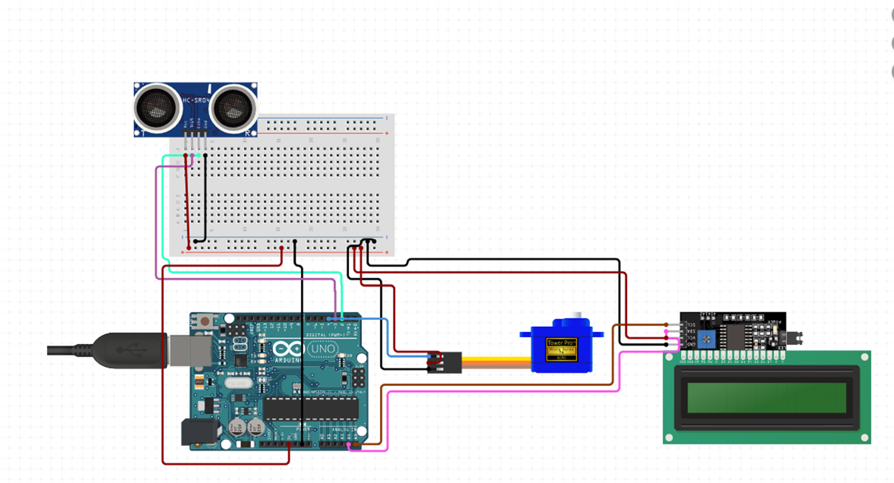

**CIRCUIT DIAGRAM**

PICTURE OF SUCCESSFUL TEST OF THE PROJECT

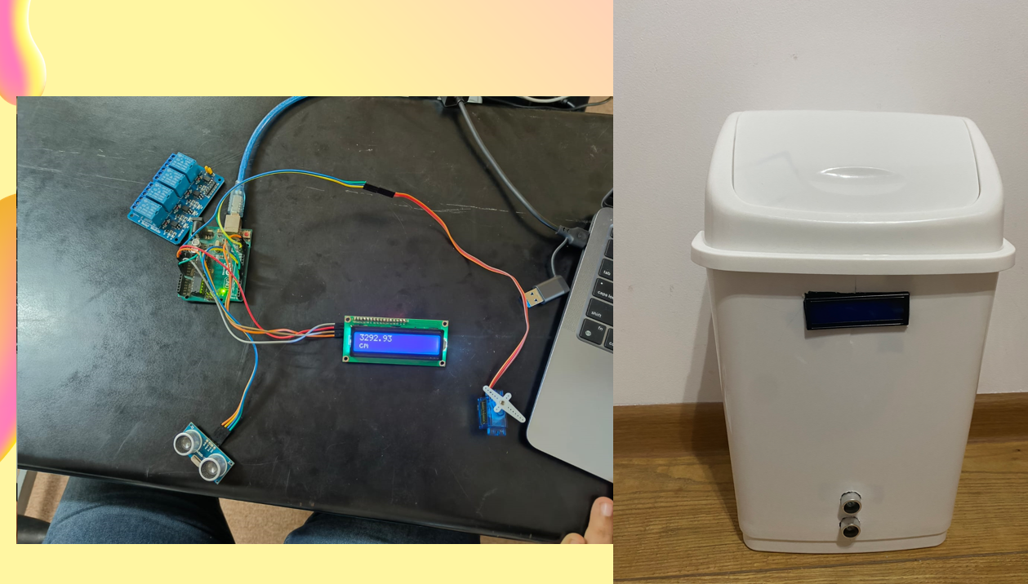

**CODE FOR THE PROJECT:**

#include <Wire.h>

#include <LiquidCrystal_I2C.h>

#include <Servo.h>

// Initialize the LCD display

LiquidCrystal_I2C lcd(0x27, 16, 2);

// Initialize the ultrasonic sensor pins

const int trigPin = 9;

const int echoPin = 10;

// Initialize the servo motor

Servo myServo;

const int servoPin = 3;

// Variables to store distance and duration

long duration;

int distance;

void setup() {

// Set up the LCD

lcd.begin();

lcd.backlight();

lcd.print("Smart Dustbin");

// Set up the ultrasonic sensor

pinMode(trigPin, OUTPUT);

pinMode(echoPin, INPUT);

// Set up the servo motor

myServo.attach(servoPin);

myServo.write(0); // Close the lid initially

// Start serial communication

Serial.begin(9600);

}

void loop() {

// Clear the LCD

lcd.clear();

lcd.setCursor(0, 0);

lcd.print("Measuring...");

// Send a 10us pulse to trigger the ultrasonic sensor

digitalWrite(trigPin, LOW);

delayMicroseconds(2);

digitalWrite(trigPin, HIGH);

delayMicroseconds(10);

digitalWrite(trigPin, LOW);

// Read the echo pin and calculate the duration

duration = pulseIn(echoPin, HIGH);

// Calculate the distance

distance = duration * 0.034 / 2;

// Print the distance on the LCD

lcd.setCursor(0, 1);

lcd.print("Distance: ");

lcd.print(distance);

lcd.print(" cm");

// Open the lid if an object is close

if (distance < 20) { // Adjust this threshold as needed

myServo.write(90); // Open the lid

delay(5000); // Keep it open for 5 seconds

myServo.write(0); // Close the lid

}

// Small delay before the next measurement

delay(2000);

}